
Lab Program Number: 36 Date: 19th March,2026
Title: Configuring SSL-Enabled Apache Server (self-signed)
- Install required for HTTPS server.
Command:
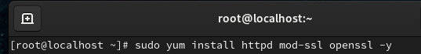
Output:
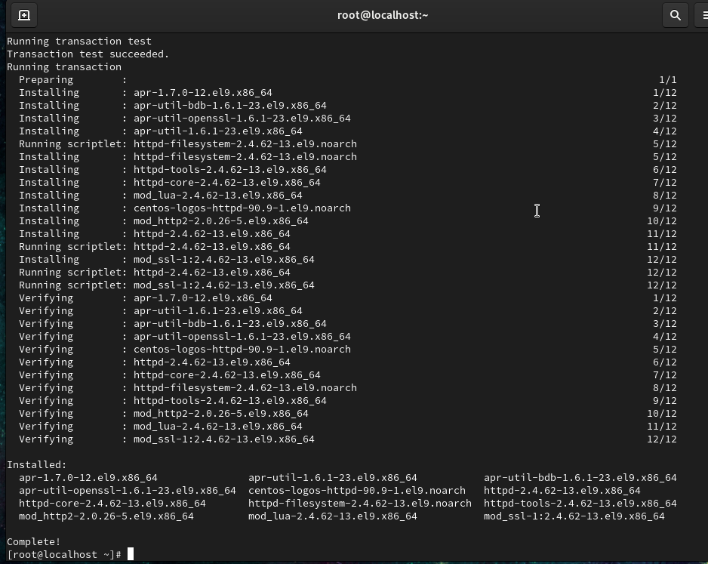
- Allow https (443) packets to enter through firewall.
Output:
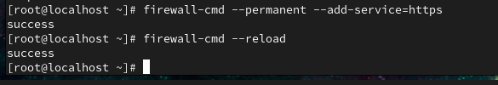
- Start & Enable service.
Output:
- Generate self-signed key & Cert files using openssl.
Command:
Output:
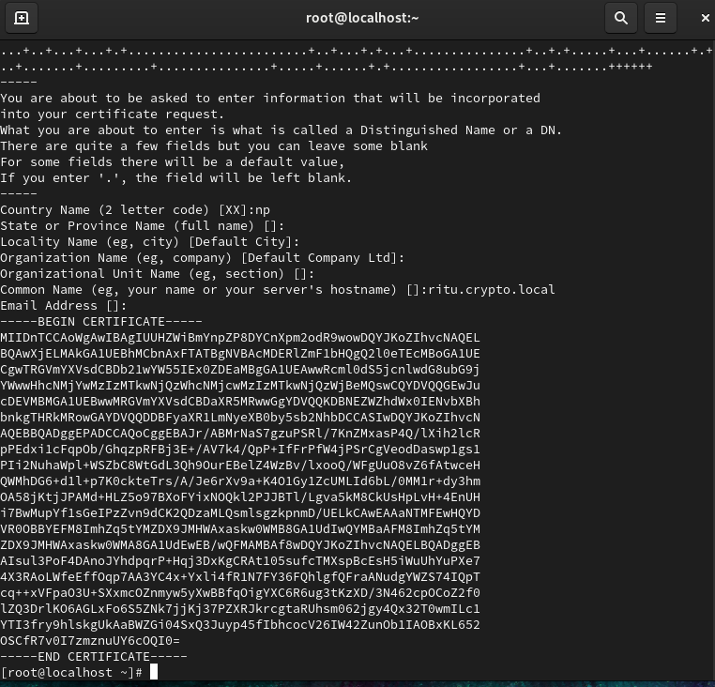

Command:
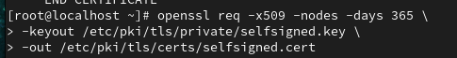
Output:


- Configure web server to listen from port 443 & set DocumentRoot to “/var/www/html”, locate the required key & cert files.
Command:
Output:
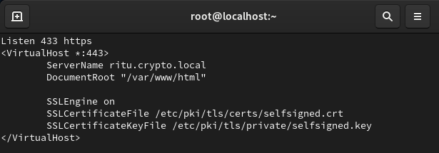

- Host a webpage called index.html on web server named <yourname>.cryptolocal.
Command:
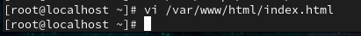
Output:
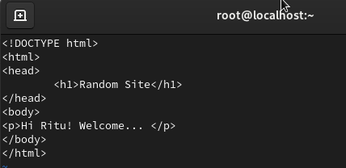

Command:
Output:
Command:
Output:
